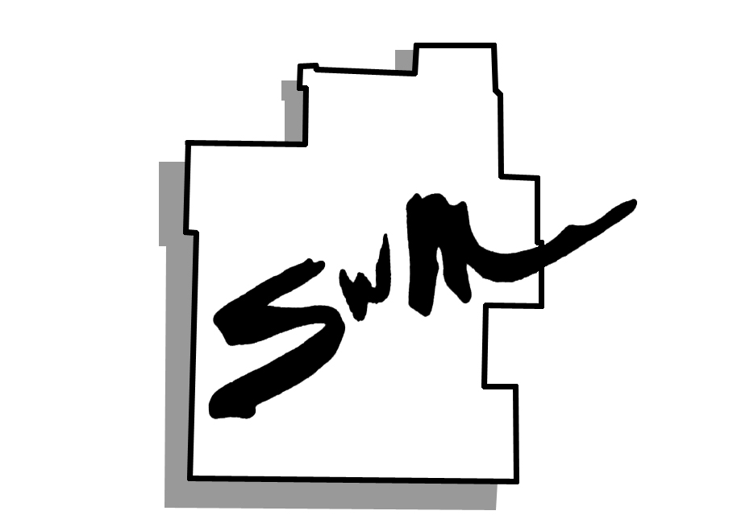
Transportation Advisory Committee Meeting
Library Station, April 9, 2014

Attending: Joel Keller, Curtis Owens, Jeff Robinson, Andrew Seiler, Nancy Edson, Todd Wiesehan, Stacy Burks, Jered Taylor, Dayton Mackey, Cherry Warren, Dennis Wood, Stan Whitehurst, Rex “Pete” Barclay, David Miller, Beth Schaller, Rick Davis
SMCOG Staff: Dan Watts

Approval of February 13, 2014 Minutes: Minutes were not available for approval due to the recording of the meeting being deleted.

Stacy Burks, Senator Blunt’s Office: Concerns about the Highway Trust fund going bankrupt sometime late this summer or fall. In order to fund the Highway Trust for 6 years it would cost 100 Million dollars. DOTs around the country are being very cautious at this time.

“Transportation Input Initiative” Prioritization Session—Jerany Jackson, Facilitator:
Ms. Jackson led the TAC in the process of prioritizing the “Road and Bridge” category of the Transportation Input Initiative. 30 road and bridge projects were reduced down to 15 during this meeting by using a consensus vote. Each project on the list was vetted one by one and TAC members from the project area spoke to the projects. Those 15 Road and Bridge projects will be presented at the MoDOT regional meeting in late May. Due to time constraints, the other modes planned for prioritization during this TAC meeting: Freight/Rail and Transit were not able to be prioritized during this meeting. A second TAC meeting date was agreed upon to finish up the process. Remaining categories are: Freight, Rail, Aviation, Transit, Bike/Ped.

Adjourn:

