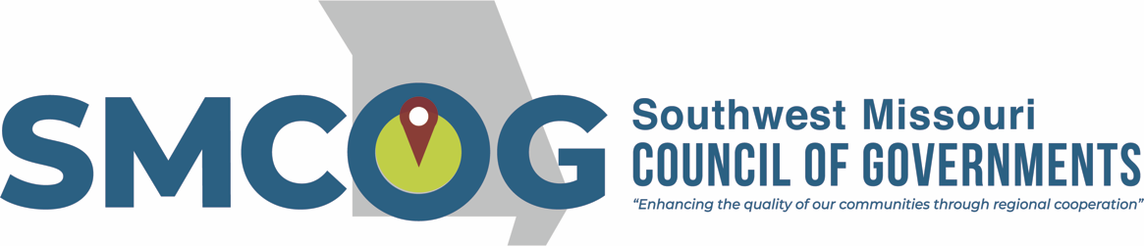

Southwest Missouri Council of Governments
Board of Directors Meeting Notice
Wednesday, January 25, 2023
9:00 a.m.
The Library Center, 4653 S.Campbell, Springfield, MO

AGENDA

Open Meeting

- Call to Order – Cindy Stephens
- Introductions and Announcements

- Approval of January 25, 2023 Meeting Agenda
BOARD OF DIRECTORS ACTION REQUESTED TO APPROVE AGENDA FOR THE
JANUARY 25, 2023 MEETING

- Approval of December 7, 2022 Meeting Minutes
BOARD OF DIRECTORS ACTION REQUESTED TO APPROVE MINUTES OF THE
DECEMBER 7, 2022 BOARD MEETING

Guest Speaker – Angie Snyder, Planner – Ozarks Headwaters Recycling & Materials
Management District
Topic: Paint stewardship legislation

Legislative Reports
- US Senator Hawley’s Office – Erin Engelmeyer
- US Senator Schmitt – Mike Ussery/Tucker Jobes
- US Congressman Burlison’s Office – Steve Helms
- US Congresswoman Alford’s Office -
- State Legislative Reports

Business

Other Business – Cindy Stephens

Partner Updates
- Ashley Venolia/Cody Green – USDA-Rural Development
- Frank Miller/Beth Schaller – MoDOT SW District
- Sara Fields/Natasha Longpine – Ozarks Transportation Organization (OTO)
- Andy Schiller/Rob Hunt – Missouri Department of Natural Resources (MoDNR)
- Ronda Burnett – Missouri Department of Conservation (MDC)
- Cynthia Collins – Ozark Region Workforce Development Board
- Jessica Tate – MO Higher Education & Workforce Development
- Theresa Sampaio – Missouri Department of Economic Development (MoDED)
- Alex Cobb – SeniorAge
- Alice Wingo – Community Foundation of the Ozarks (CFO)
K. Stacy Burks – Red Cross

Member Updates – This is an opportunity for SMCOG members to provide updates or introduce items of regional concern for discussion.

Adjourn
Next SMCOG Board Meeting: March 22, 2023

This meeting is open to the public in accordance with Missouri law. A copy of this agenda was posted for public view at the SMCOG office at 110 Park Central Square, Springfield, MO 65806 on January 20, 2023 and online at smcog.org.

SMCOG complies with Title VI of the Civil Rights Act of 1964 and related statutes and regulations in all programs and activities. For more information or to obtain a Title VI Complaint Form, see www.smcog.org, or call (417) 836-6900. Persons who require special accommodations under the Americans with Disabilities Act or persons who require translation services (free of charge) should contact Jane Hood at (417) 836-6273 at least 4 working days prior to the meeting date.

